COMENIUS PARTNERSHIPS
„Helpnig schools team up across Europe“
Brussels, 3-4 May 2012
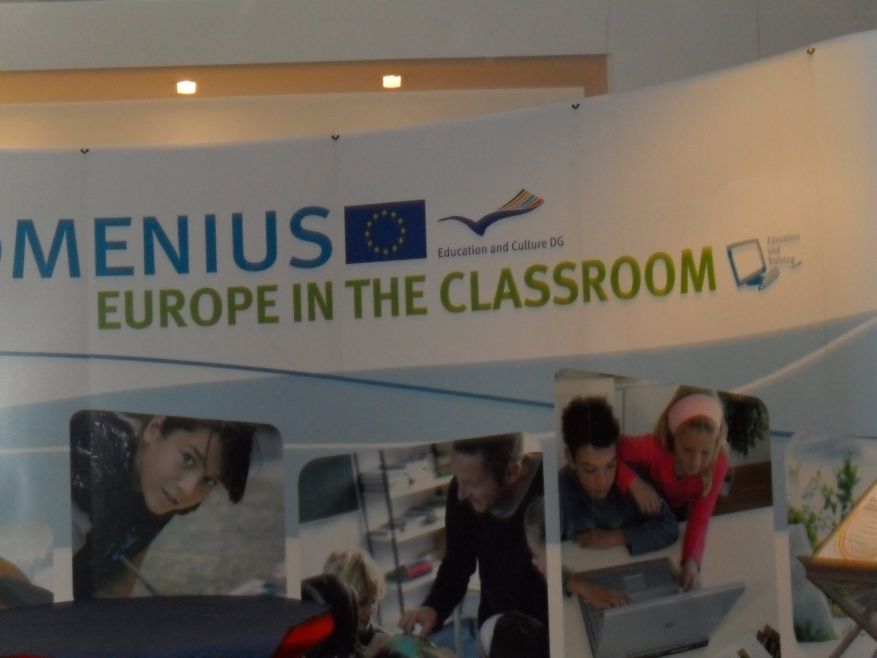
The conference took place in Conference Management Centre Europe, Rue de l'Aquedoc 118 from 3-4 May.It gathered more than 250 participants from different institutions : Ministries, National Agencies, ESHA, European network Connection Council, ETUCE, General Heading Conuncil etc. and representatives of primary and secondary schools included in Comenius programme. Four schools from Croatia were present: Economic school Mijo Mirković,Gimnazija Matije Antuna Reljkovića Vinkovci, Centar za odgoj i obrazovanje „Slava Raškaj“, Zagreb and Privatna ekonomska škola INOVA, Zagreb. Representatives of each school were partcipating in one of four thematic workshops.
Agenda: 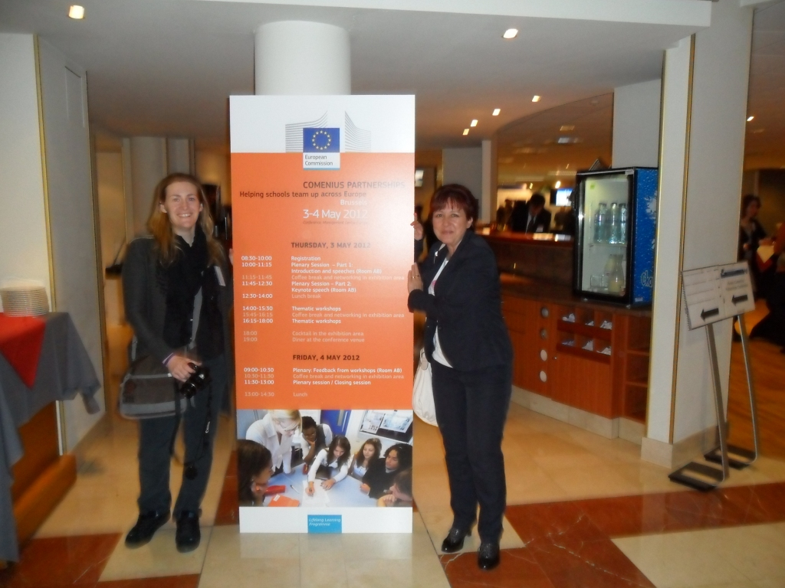
May 3 ^{rd}
10-11'15 Plenary session
Welcoming speech by Antonio Silva Mendes Director, European Commision
Keynote speech by professor Klaus Hurrelman, Hertie School of Governance, Germany „Current challenges of school education“
11'45-12'30 plenary session
Keynote speech by Paul Collard, Chief executive of Creativity,Culture and Education (CCE) United Kingdom „Can external partnerships bring about real challenge in schools?The case of Creative partnerships programme“
14'00-18'00
Thematic workshops:
1.Turning schools into 21st century learning environment
This workshop looked up at the challenges schools face when trying to adapt to changing environments. Focusing on the example of ICT it tried to answer on how the school patnerships can help improve learning enviroments and to what extent.
2. Improving teacher competences
Different ways in which teacher education can support teachers in their tasks from their initial education, during the first years on the profession and continuous development throughout their careers.It focused on both competences and talents, weaknesses and strenghts, and take into account the social demand and requiremets set out in the European and national policies, and individual motivations and personal interpretations of the proffesionals involved.
3. Schools that work for everyone
One of the main issues raised by teachers and school leaders is the incresingly diverse nature of pupils backgroudns and abilities.How can school contribute to creating implementing and sharing successful inclusive approaches to teaching and learning?
4. „Supporting the internationalisation of schools“was the theme which I have chosen to participate in.
The workshop focused on the ways in which the internationalisation of schools gives added values to the learning process in the schools, how it can help students gain their language skills, get to know and connect with thieir peers in other European countries and learn to work together becoming confident world citizens.It explored the ways in which teachers and schools can engage pupils in international work, exploit the opportunities available and how to connect the international cooperation in the curriculum.

Successful projects were presented in the exibition area as an example and a starting point for new ideas development.
May 4th
9'00 – 10'30 Plennary session
Feedback from workshops
- Turning schools into 21st century learning environment
Looking on the impact on web tools on student motivation
Benefits:motivating more teachers to use them, motivating students to learn by themselves,making users tehnologically aware and savvy,use of evaluation tool and use of survey
How schools can work together:agree on evaluation tool and set it up,using Moodle,Google docs,Facebook/Twitter,Skype
Bridging culture through technology at all levels of capability internationally
Benefits: culture awareness and knowledge,encourage extended use of languages,enhaced use of ICT,presentation skills,bridge the geographical gap,creative/motivational learning.
- Improving teacher competences
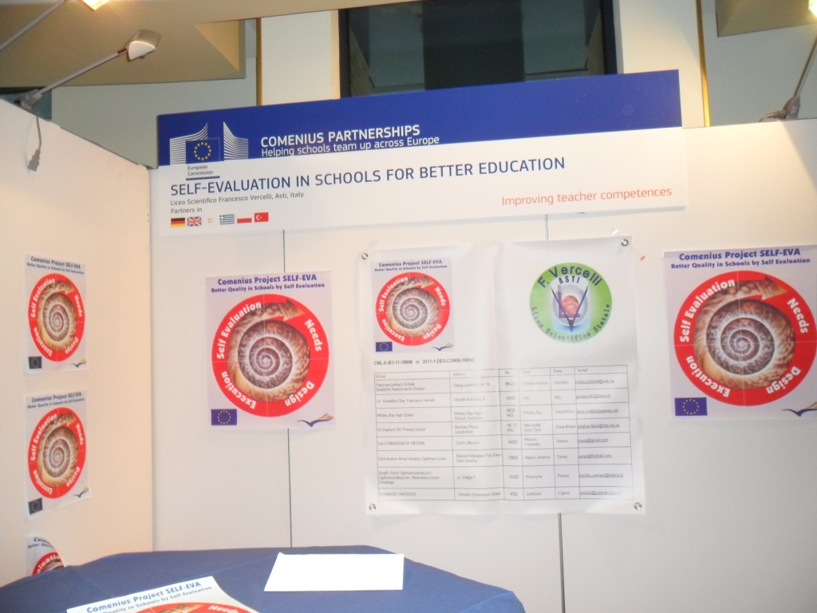The four approaches:support teachers to be fully aware of their competences and strenghts,support teachers to be agents of postive change in constantly changing environment,teachers and pupils working together to catch „the right fish“ in vast and stormy ICT sea,the same teacher in different context is different (UNESCO'S four pillars of education).
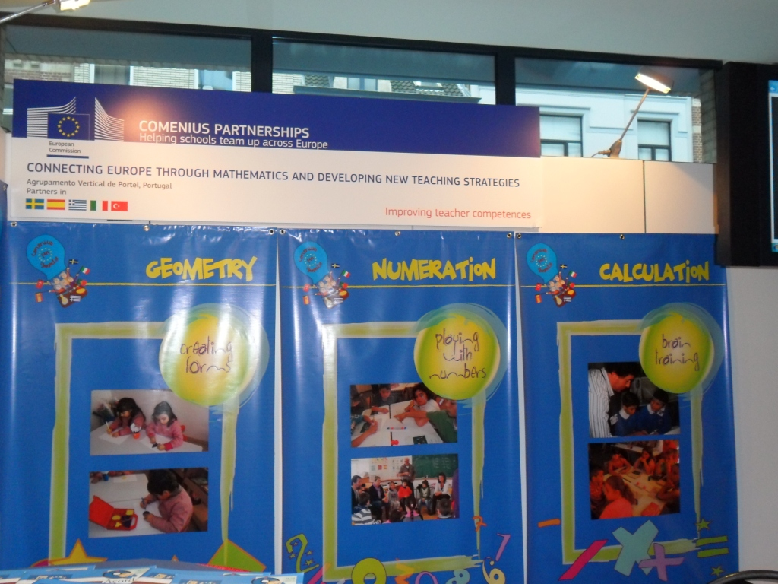
3. Schools that work for everyone
The four approaches:making better use of students and teachers as resources,mixing academical and practical learning, teacher's classroom, multiprofessional support for teachers,building on strenghts with parents. Except working with regular students this workshop established basics for inclusive approach in teaching/learning processes.
- „Supporting the internationalisation of schools“
- Support point for internationalisation
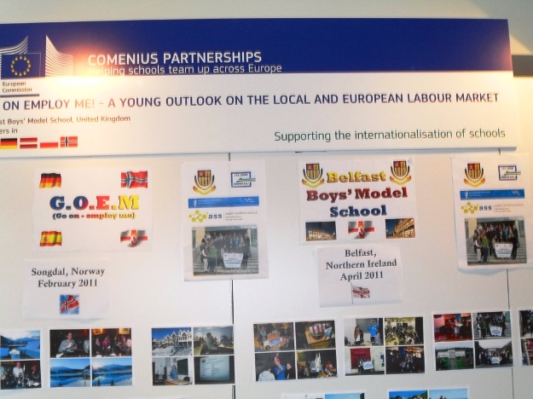Based in the schools themselves (e.g.office),simplifies access to information, a place and/or virtual point, means to organise events and to display information. Benefits:better information for pupils,teachers,schools and a community,information is available locally and is provided by the schools themselves,involvement of teachers and students,increased motivation for teachers.
- International coordinator-one stop shop on all internationalisation questions,it may be a teacher, volunteer,it depends on what's in it for schools,coordinator is working closely with head of the school
Benefits:a single contact person for communication and information, good opportunities for the pupils, for the school (international profile of the school,a Unique selling point, teacher who takes the position- continuous professional development),coordinator is the repository of information
- Teaming up
First step: CLIL becomes the part of the school policy, this would lead teachers to teamworking,teachers would be developing their language skills and work together within the school and internationally.
Benefits: increased value (development of teachers' language skills,attracting more students) to the school,teams of enthusiastic teachers appear in the school,acquisition and exchange of external experience,CLIL becomes an and and a starting point
- Stairway to A global view
Towards a universal internationalised curriculum,schools would compare their subjects and put everything in the international perspective,analysis of the curricula and gradual harmonisation,gradual, therefore the stairway
Benefits:friendships between the students,knowledge of other educational systems,education and involvement of parents in international approach,emphasising the globalisation aspects of the subject curriculum.
Information from workshops will be a starting point for future action and developing new partnerships.
11'30-12'30 Plenary session „Erasmus for all“ 2014-2020 (what's in it for schools)

Sanja Čop-Barbarić, headmistress

